

INDIVIDUAL ASSIGNMENT

CT101-3-3-IOT

Internet of Things: Concepts and Applications

APD3F2505CS(CYB)

HAND OUT DATE: 24 May 2025

HAND IN DATE: 18 August 2025

Lecturer: Kamalanathan Shanmugam

By: Shady Ehab Assad Ibrahim (TP073549)
1.0 Table of Contents
1.1 INTRODUCTION 2
2.0 Components Required 3
2.1 Maker UNO 5
2.2 Long Breadboard (16.5 cm x 5.5 cm) 6
2.3 RFID-RC522 Card Reader Module 7
2.4 2x16 LCD with I2C Module 8
2.5 SG90 Micro Servo 9
2.6 Mifare Card 10
2.7 passive buzzer 11
2.8 LED (red, green, yellow 12
2.9 Male to Male Jumper Wires 13
2.10 Male to Female Jumper Wires 14
2.11 Resistor 220 ohm 15
2.12 Arduino IDE 16
3.0 System Design 17
3.1 Step 1: Connecting Maker UNO with Breadboard And add Resistor 17
3.2 Step 2: Connecting Ultrasonic Sensor, LEDs, and Buzzer with the Maker UNO 18
3.3 Step 3: Connecting RFID-RC522 Card Reader and LCD display 19
3.4 Step 4: Connecting Servo Motor with the Breadboard 20
4.0 Prototype Screenshot 21
5.0 Source Code 22
6.0 Limitations 35
7.0 Future Enhancement 35
8.0 Conclusion 35
9.0 Reference 36

INTRODUCTION
The realisation of the internet-of-things (IoT) has allowed for smart, automated and secure solutions that incorporate sensors, actuators and microcontrollers to solve various problems. Arduino, an open-source electronics platform based on easy-to-use hardware and software, is a very popular prototyping tool for IoT applications because of its simplicity, low cost, and easy to implement. Arduino is a robust ecosystem for rapid prototyping of groundbreaking ideas, with hardware components (sensors, actuators and displays) combined with programmable logic in the area of automation, security and industrial monitoring.
Now, in this we implement an Ultrasonic RFID Security Gate System. It detects the closeness of people to a limited area using an ultrasonic sensor. Three LEDs (green, yellow and red) and a buzzer give instant visual and audio feedback, showing if it is safe to step on the area (green), or you should wait for caution (yellow) or if restricted zone has been entered. For security, the system is also equipped with an RFID (Radio Frequency Identification) module where only authorized personnel is able to scan their RFID card for it to allow access. There is a physical gate with the servo motor which opens only when the authenticated person) Also it uses an LCD display to give user feedback and instructions in real time.
The purpose of this project is to show an actual usage of Arduino (supported by approach with sensor monitoring) within cybersecurity-related fields: access control. This project integrates multiple parts illustrating the real-life practicality of solving IoT issues wherein safety, automation and security are involved in an overall scope through Arduino.

Components Required
No. | Component | Quantity
1 | Arduino Uno R3 | 1
2 | Ultrasonic Sensor (HC-SR04) | 1
3 | RFID Module (MFRC522) | 1
4 | RFID Cards | 1
5 | Servo Motor (SG90) | 1
6 | Buzzer | 1
7 | LEDs (Green, Yellow, Red) | 3
8 | Resistors (220Ω / 330Ω) | 4
9 | Liquid Crystal Display (LCD 16x2 with I2C) | 1
10 | Breadboard | 1
11 | Jumper Wires (Male–Male, Male–Female) | 23
12 | Power Supply (USB cable or 9V Adapter) | 1

Maker UNO
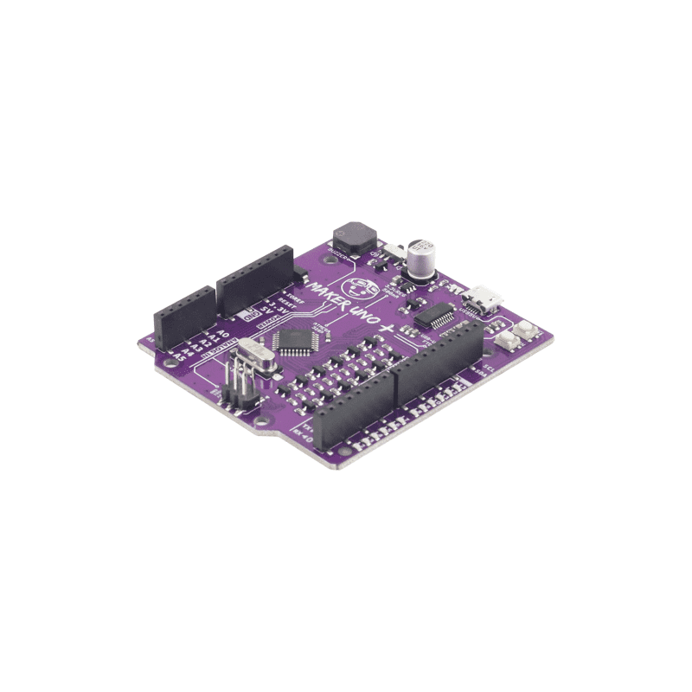
Figure 1:Maker UNO
The Maker UNO, an Arduino-compatible board based on the ATmega328P, is the main controller for the Ultrasonic RFID Security Gate System. Though it has built-in LEDs and a buzzer, external components are added for better functionality: a passive buzzer for louder alarms and LEDs for clear status indication (green = safe, yellow = warning, red = alert). The Maker UNO provides reliability, easy integration, and real-time control, while external parts make the system more practical and scalable for security applications.

Long Breadboard (16.5 cm x 5.5 cm)
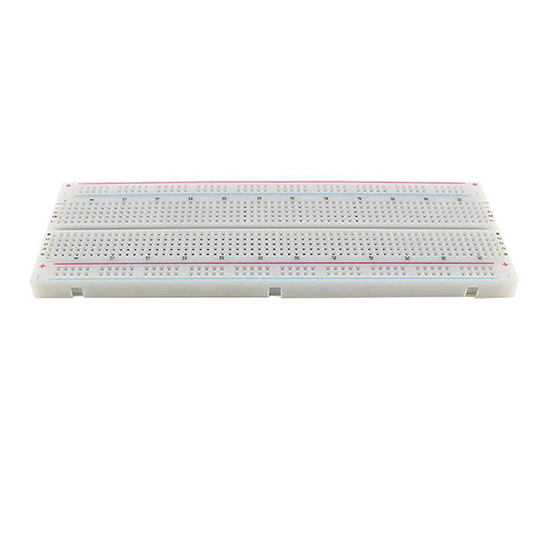
Figure 2:Long Breadboard (16.5 cm x 5.5 cm)
The breadboard is a reusable prototyping tool that connects components without soldering. In this project, a full-size board (16.5 × 5.5 cm) is used to assemble the Ultrasonic RFID Security Gate System, hosting the ultrasonic sensor, RFID reader, buzzer, and LEDs. Its power rails distribute 5V and GND, while its flexible layout allows easy wiring, troubleshooting, and adjustments, making it cost-effective for testing complex circuits.

RFID-RC522 Card Reader Module
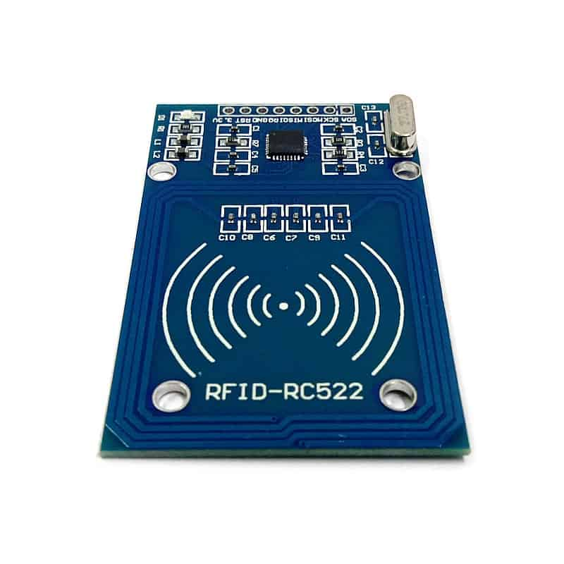
Figure 3:RFID-RC522 Card Reader Module
The RFID-RC522 is a compact, low-cost reader operating at 13.56 MHz, commonly used for access control. It communicates with the Maker UNO via SPI protocol to quickly read the UID from RFID cards or key fobs. In this project, it acts as the authentication unit of the Ultrasonic RFID Security Gate System. When a card is scanned, the UID is checked against stored authorized IDs granting access if valid and denying it otherwise. Its ease of use with Arduino libraries and compatibility with many tags make the RC522 both practical and reliable for security applications.

2x16 LCD with I2C Module

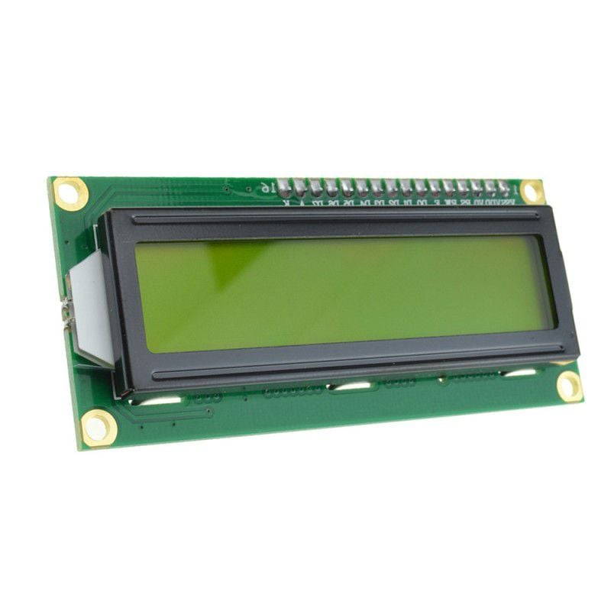
Figure 4:2x16 LCD with I2C Module
The 2x16 LCD is a common display module that shows two rows of text, useful for system status and user feedback. To save pins, an I2C interface is added, reducing connections to only SDA, SCL, power, and ground. This leaves more I/O pins on the Maker UNO for other components. In this project, the LCD displays real-time messages such as “Access Granted,” “Access Denied,” or “Scan Your Card,” giving users clear and immediate feedback, which improves the system’s usability and reliability.

SG90 Micro Servo

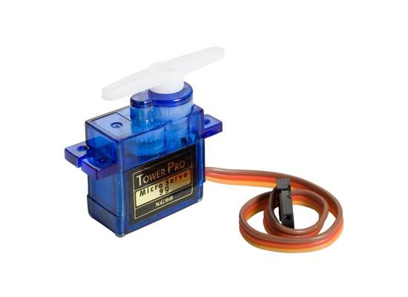
Figure 5:SG90 Micro Servo
The SG90 Micro Servo is a small, lightweight actuator that provides precise angular control between 0° and 180° using PWM signals. Unlike motors that spin continuously, it can be positioned accurately, making it ideal for locks, barriers, and robotic applications. In this project, the SG90 acts as the gate mechanism of the Ultrasonic RFID Security Gate System, opening when a valid RFID card is scanned and staying locked otherwise. Its low cost, efficiency, and easy integration with Arduino libraries make it a reliable choice for security and automation projects.

Mifare Card
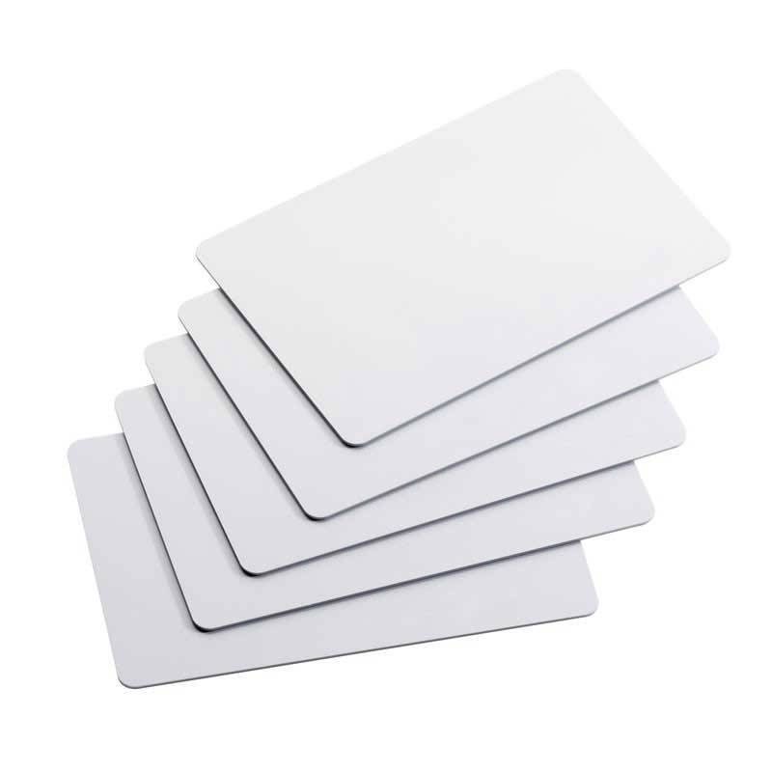
Figure 6:Mifare Card
The MIFARE Card is an RFID smart card operating at 13.56 MHz, commonly used in access control, transport, and cashless payment. Each card has a unique UID that can be verified to prevent unauthorized use. In this project, the MIFARE Card works with the RC522 RFID reader to provide the physical access layer of the Ultrasonic RFID Security Gate System. When scanned, the UID is checked by the Maker UNO against stored IDs; if valid, the servo unlocks the gate, otherwise access is denied. Its low cost, reliability, and availability make MIFARE Cards ideal for secure yet affordable authentication.

2.7 passive buzzer
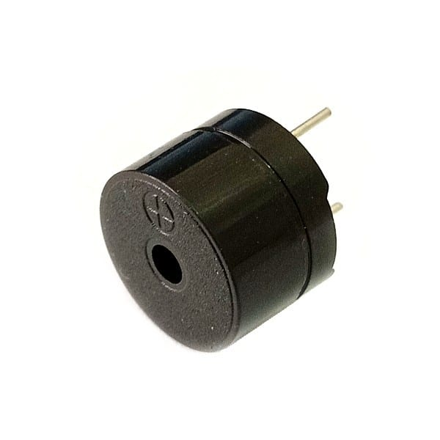

The MIFARE Card is an RFID smart card operating at 13.56 MHz, commonly used in access control, transport, and cashless payment. Each card has a unique UID that can be verified to prevent unauthorized use. In this project, the MIFARE Card works with the RC522 RFID reader to provide the physical access layer of the Ultrasonic RFID Security Gate System. When scanned, the UID is checked by the Maker UNO against stored IDs; if valid, the servo unlocks the gate, otherwise access is denied. Its low cost, reliability, and availability make MIFARE Cards ideal for secure yet affordable authentication.

  - LED (red, green, yellow)

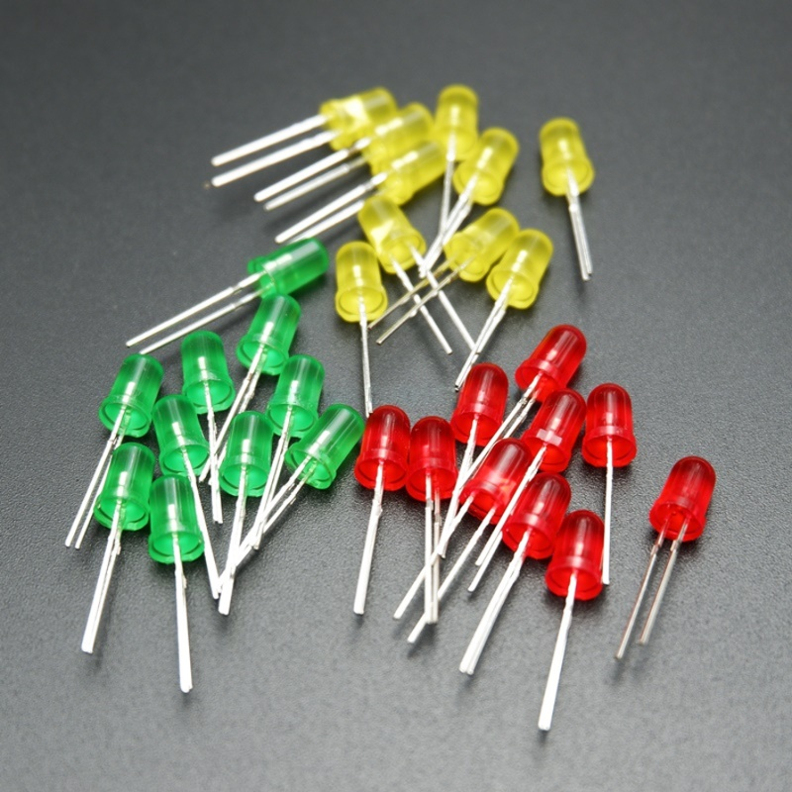
Figure 7:LED (red, green, yellow)
LEDs (Light Emitting Diodes) are efficient visual indicators known for low power use and fast response. In this project, three LEDs provide traffic-light-style feedback: the Red LED signals unauthorized access at a critical distance, the Yellow LED prompts users to scan their RFID card in the warning zone, and the Green LED shows a safe condition. This simple red-yellow-green system gives users clear, intuitive status information at a glance.

Male to Male Jumper Wires
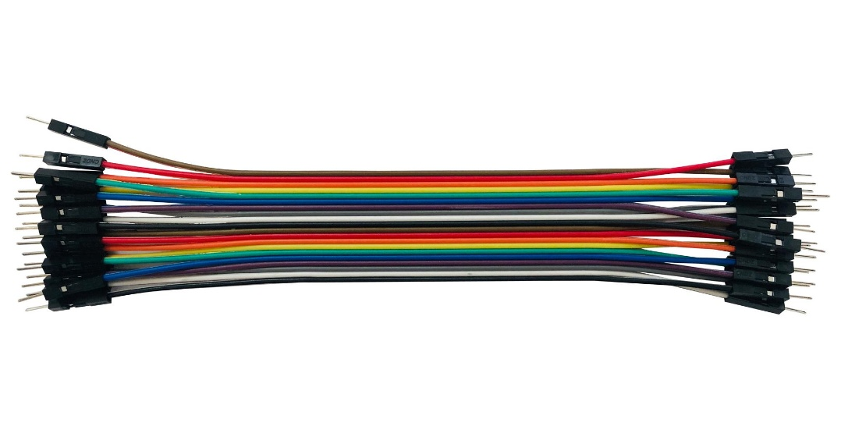
Figure 8: Male to Male Jumper Wires
Male-to-Male Jumper Wires are used to connect the Maker UNO with components through the breadboard. Each wire has pins on both ends, making them ideal for quick and adjustable connections during prototyping. In this project, they link the LCD, RFID reader, LEDs, passive buzzer, and servo motor to the microcontroller. Their reusability, flexibility, and color coding simplify testing, reduce wiring errors, and make troubleshooting easier, making them essential for building the Ultrasonic RFID Security Gate System.

Male to Female Jumper Wires
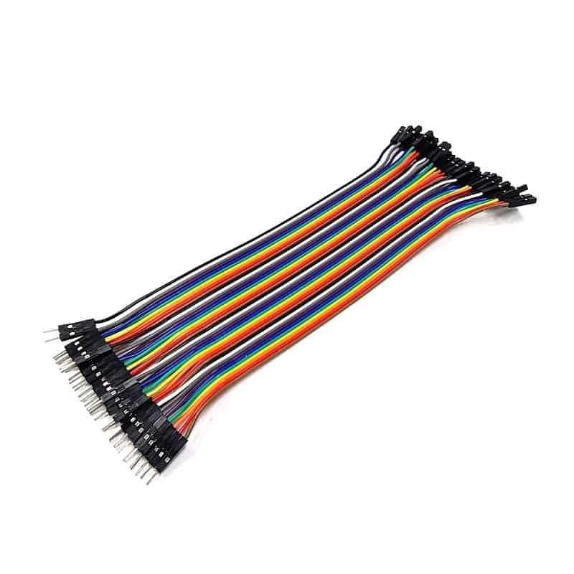
Figure 9:Male to Female Jumper Wires
Male-to-Female Jumper Wires are used to connect modules directly to the Maker UNO, especially those not breadboard-friendly. Each wire has a male pin for module headers and a female socket for the UNO or breadboard jumpers. In this project, they connect the RFID-RC522 module, I2C LCD, and SG90 servo motor. Since most parts have male header pins, these jumpers provide secure connections, reduce loose wiring issues, and ensure reliable communication between the controller and external devices.

Resistor 220 ohm
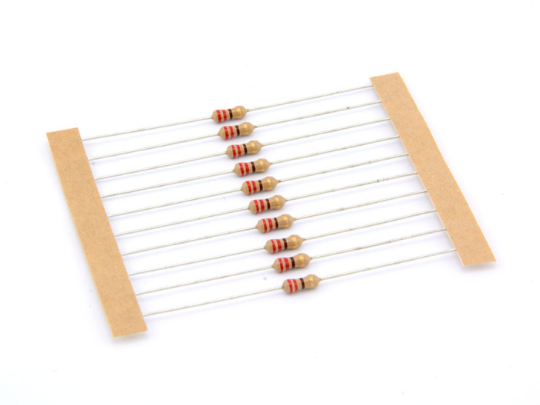
Figure 10:Resistor 220 ohm
The 220-ohm resistor protects both the LEDs and the Arduino board from excessive current. Without it, LEDs could overheat or damage the microcontroller pins. In this project, one resistor is used for each LED (red, yellow, and green) to regulate brightness safely. A resistor is also applied to the passive buzzer to prevent excess current that could affect sound quality or harm the Arduino. Though small, the 220-ohm resistor is vital for ensuring safe and reliable operation of the system.

2.12 Arduino IDE

Figure 11:Arduino IDE
The Arduino IDE is the software used to write, compile, and upload code to the Arduino board. In this project, it coordinates all components of the Ultrasonic RFID Security Gate System, including the LEDs, ultrasonic sensor, RFID module, servo motor, buzzer, and LCD. By managing inputs, decisions, and outputs in one program, the IDE ensures the system runs smoothly and responds in real time.

3.0 System Design
The Ultrasonic RFID Security Gate System was first designed and tested in Tinkercad, a web-based circuit simulation tool. Components such as the Arduino, sensors, and actuators were placed on a virtual breadboard, wired, and debugged in real time. Tinkercad allowed us to view distance readings, LED changes, buzzer sounds, LCD messages, RFID scans, and servo movements before hardware implementation. This reduced wiring errors, protected sensitive modules like the 3.3V RFID reader, and sped up testing of logic, thresholds, and timings.

3.1 Step 1: Connecting Maker UNO with Breadboard And add Resistor
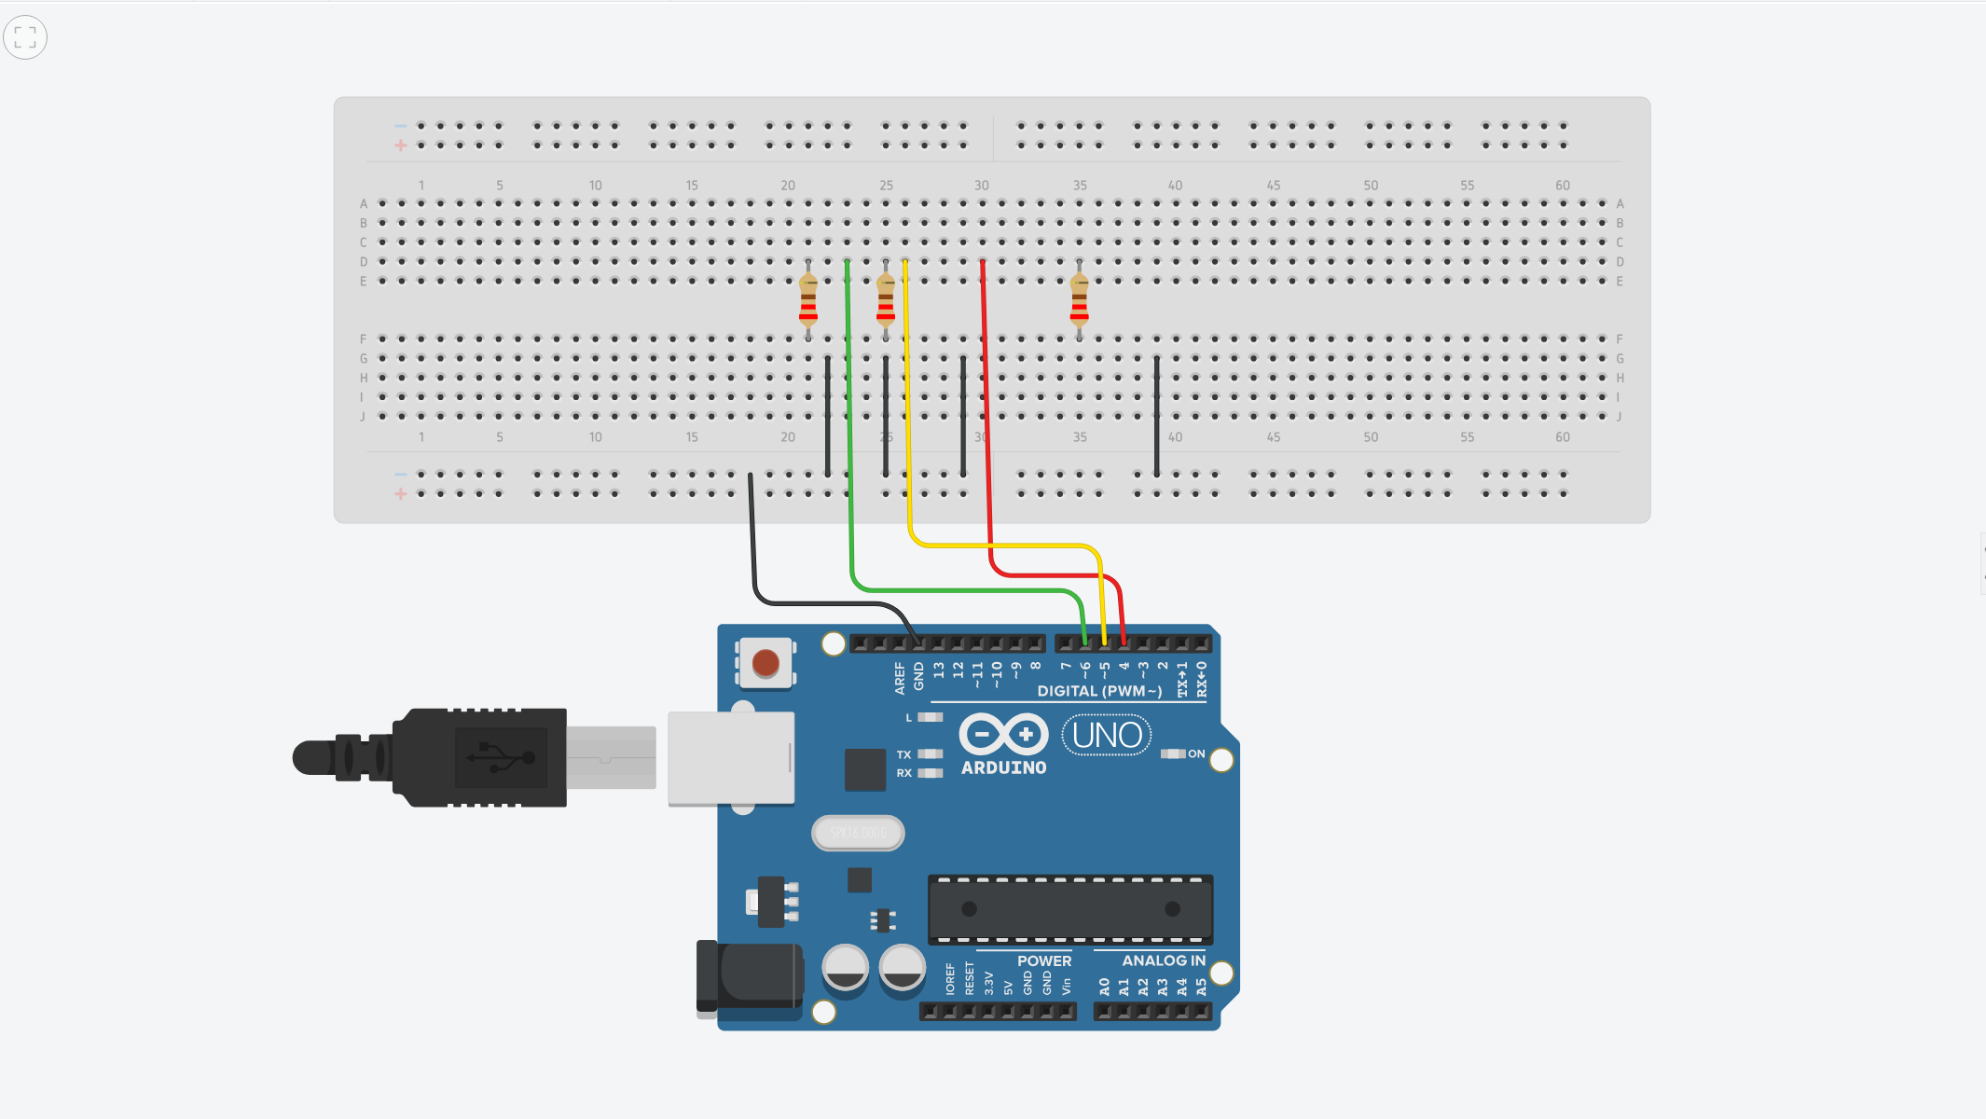
Figure 12: Base Circuit
The Arduino UNO powers the breadboard by linking 5V to the positive rail and GND to the negative rail. Digital pins D4, D5, and D6 are routed through resistors to prepare for LEDs, forming the foundation of the circuit.

Arduino UNO Pin | Breadboard Connection | Component Connected
GND | Negative (blue) rail | Breadboard Ground
D4 | Series resistor - Breadboard row | LED (Anode)
D5 | Series resistor -Breadboard row | LED (Anode)
D6 | Series resistor -Breadboard row | LED (Anode)

3.2 Step 2: Connecting Ultrasonic Sensor, LEDs, and Buzzer with the Maker UNO
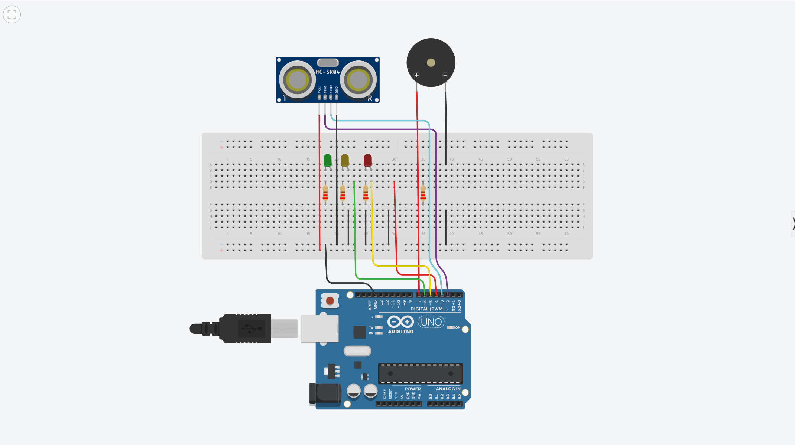
Figure 13:LEDs, Ultrasonic Sensor, and Buzzer
Three LEDs (red, yellow, green) are added via resistors to D4–D6, with cathodes grounded. An HC-SR04 ultrasonic sensor connects on D2 (Trig) and D3 (Echo) to measure distance, while a buzzer on D7 provides alarms for unauthorized access.

3.3 Step 3: Connecting RFID-RC522 Card Reader and LCD display
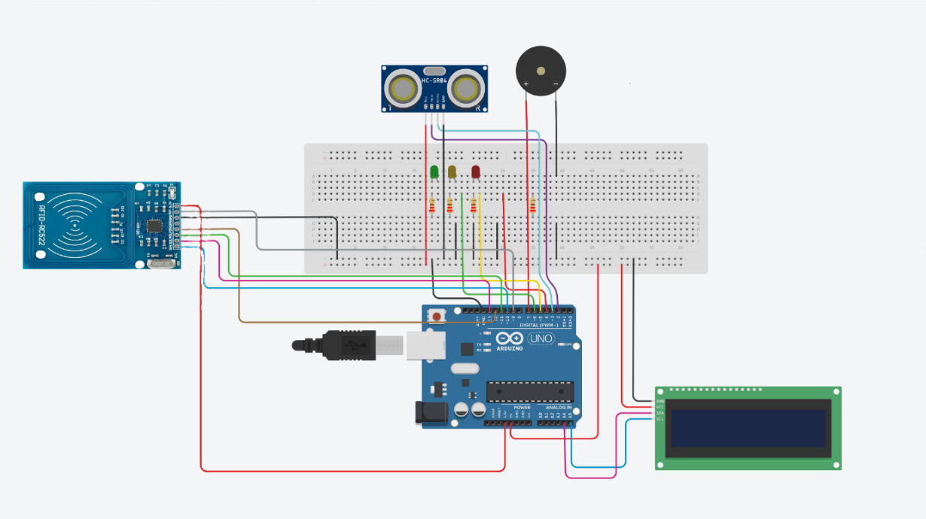
Figure 14:RFID Module and LCD Display
The RC522 RFID module connects via SPI (SDA D10, MOSI D11, MISO D12, SCK D13, RST D9) powered by 3.3V, enabling card scanning. A 16×2 LCD with I2C connects on SDA A4 and SCL A5 to display system messages like “Access Granted” or “Access Denied.”
Arduino UNO Pin | Breadboard Connection | Component Connected
5V | Positive (red) rail | Breadboard Power
GND | Negative (blue) rail | Breadboard Power
D2 | Trigger pin (TRIG) | HC-SR04 Ultrasonic Sensor
D3 | Echo pin (ECHO) | HC-SR04 Ultrasonic Sensor
D4 | Series resistor - LED anode | Red LED
D5 | Series resistor - LED anode | Yellow LED
D6 | Series resistor - LED anode | Green LED
D7 | Positive terminal | Passive Buzzer

3.4 Step 4: Connecting Servo Motor with the Breadboard
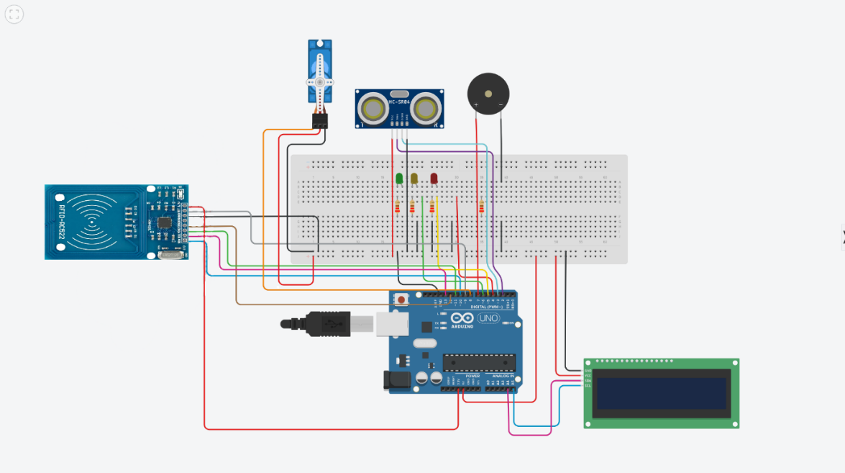
Figure 15:Servo Motor Integration
A servo motor on D8 acts as the gate, rotating to open when a valid RFID card is scanned and closing automatically after a delay. This completes the prototype with sensing, authentication, feedback, and actuation.
Arduino UNO Pin | Connected To | Component
D9 | RST | RFID RC522
D10 | SDA | RFID RC522
D11 | MOSI | RFID RC522
D12 | MISO | RFID RC522
D13 | SCK | RFID RC522
3.3V | VCC | RFID RC522
GND | GND | RFID RC522
D8 | Signal pin | Servo Motor (SG90)
5V | VCC | Servo Motor (SG90)
GND | GND | Servo Motor (SG90)
A4 (SDA) | SDA | I2C LCD
A5 (SCL) | SCL | I2C LCD
5V | VCC | I2C LCD
GND | GND | I2C LCD

4.0 Prototype Screenshot

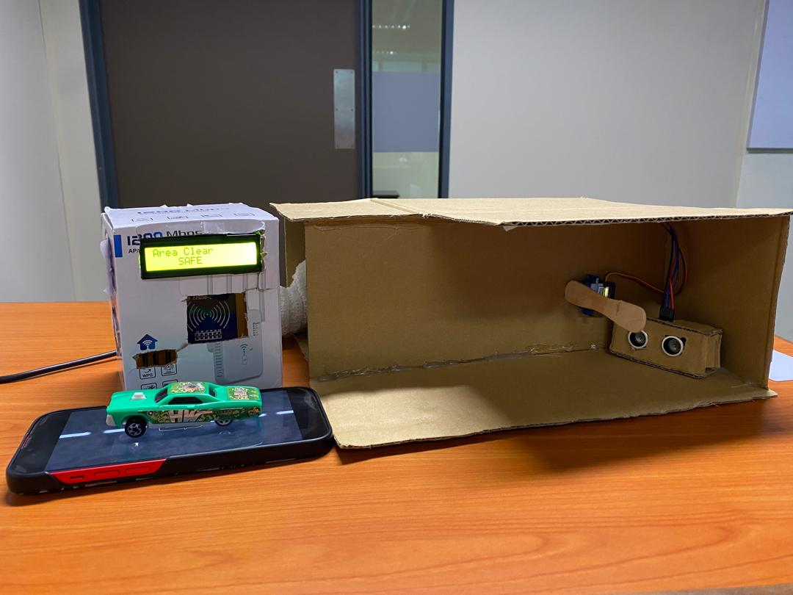
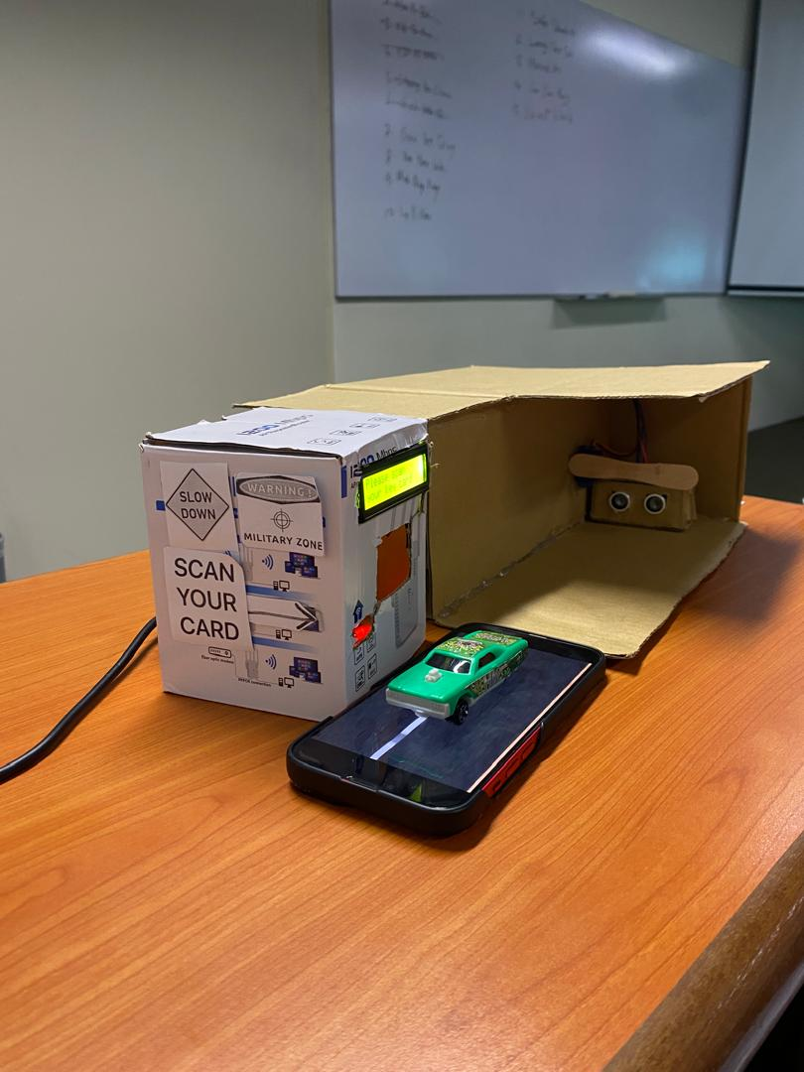

5.0 Source Code
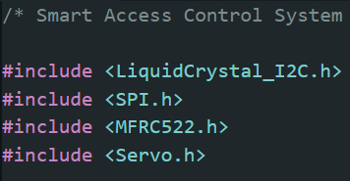
Figure 17:Arduino Code Libraries
This section of code includes the necessary libraries for the Ultrasonic RFID Security Gate System: LiquidCrystal_I2C.h for the LCD, SPI.h and MFRC522.h for RFID card reading, and Servo.h for controlling the servo motor. These libraries simplify hardware communication and system control.
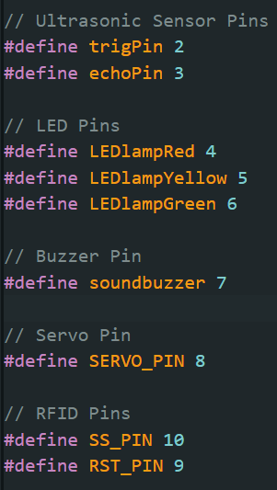
Figure 18:Pin Definitions
This part of the code maps the Arduino pins to the hardware used in the Ultrasonic RFID Security Gate System. The ultrasonic sensor is connected to pins 2 (Trig) and 3 (Echo), the three LEDs to pins 4 (Red), 5 (Yellow), and 6 (Green), the buzzer to pin 7, and the servo motor to pin 8 for gate control. The RFID module is assigned to pins 9 (RST) and 10 (SS). These pin definitions keep the program organized and make it easier to manage or update connections.
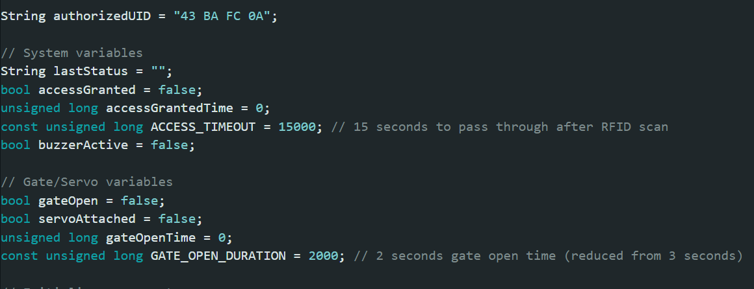
Figure 19:System and Gate Variables
This part of the code sets key variables for access and gate control. The authorizedUID stores the valid RFID card ID, while system variables manage access status, buzzer alerts, and a 15-second timeout. Gate variables track whether the gate is open, servo attachment, and control the auto-close duration (set to 2 seconds). These ensure secure and timed operation of the system.
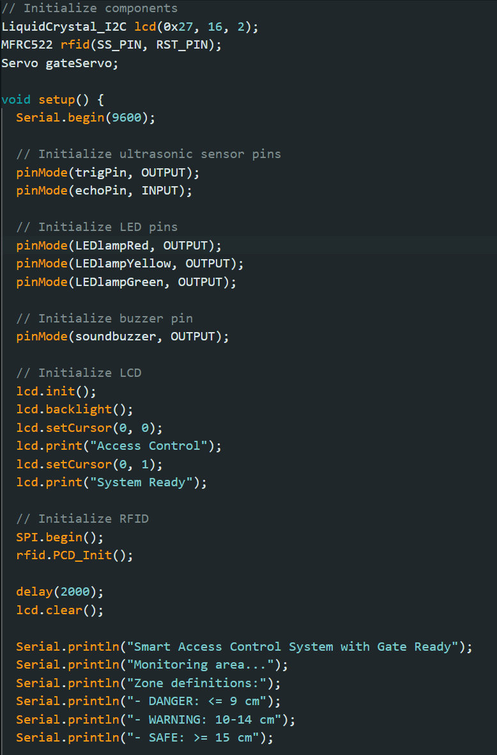
Figure 20:Setup Function
This code section initializes all system components: the ultrasonic sensor, LEDs, buzzer, LCD, and RFID module via SPI. The LCD first displays a welcome message, then clears to show readiness. Serial Monitor defines the zones Danger (≤5 cm), Warning (10 cm), and Safe (≥20 cm)—to help users and developers understand the system’s initial state.
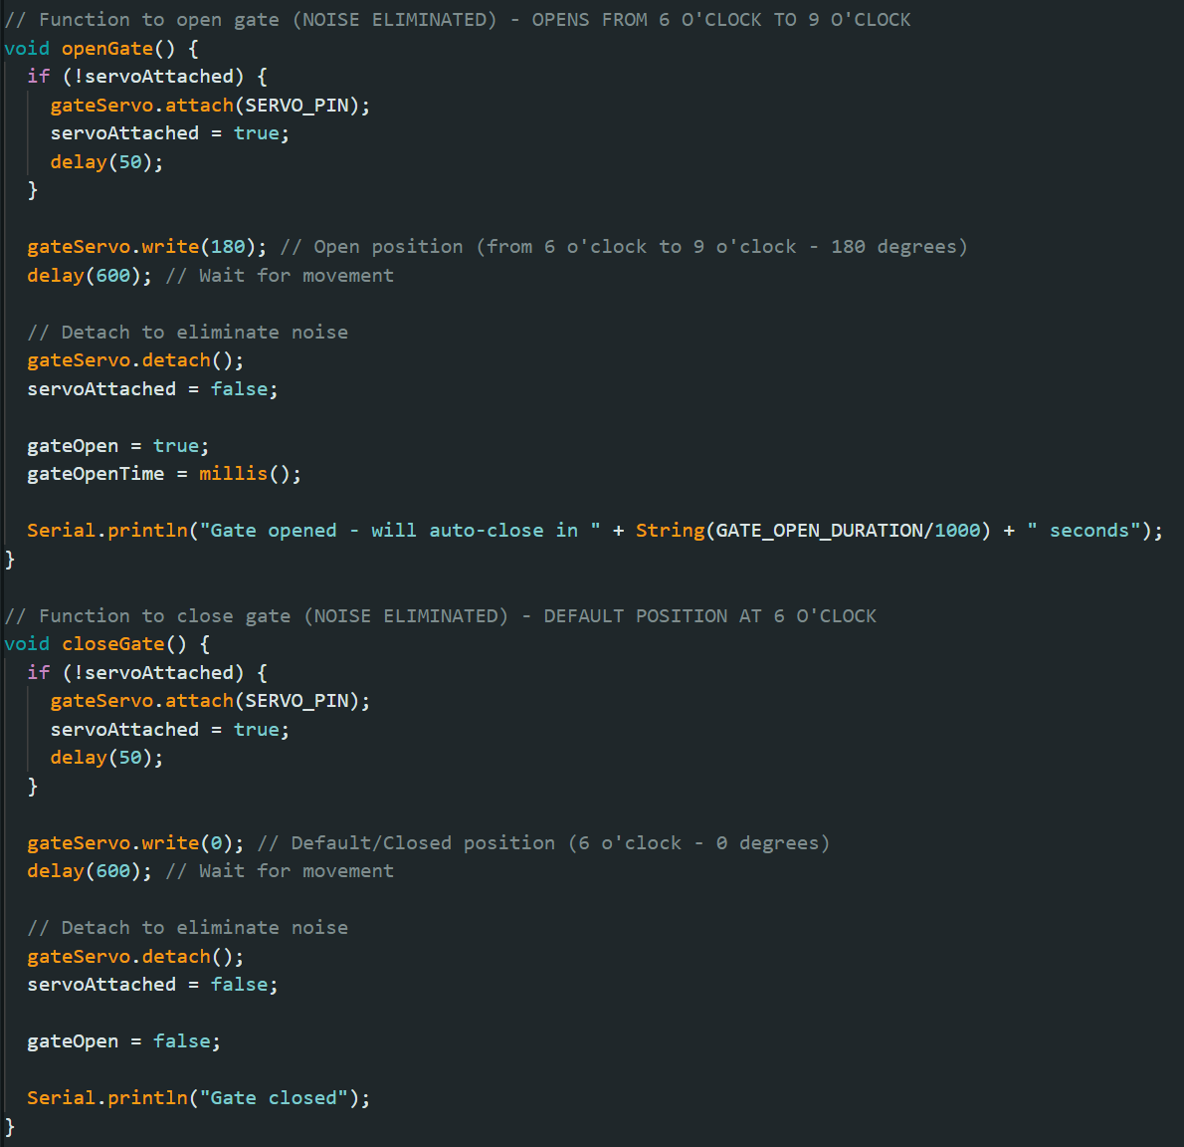
Figure 21:Gate Control Functions
This section controls the servo for gate movement. openGate() rotates the servo to 180° (open), updates the state, detaches to reduce noise, and logs the auto-close time. closeGate() reattaches the servo, returns it to 0° (closed), then detaches again. Together, they ensure smooth, quiet, and precise gate operation.

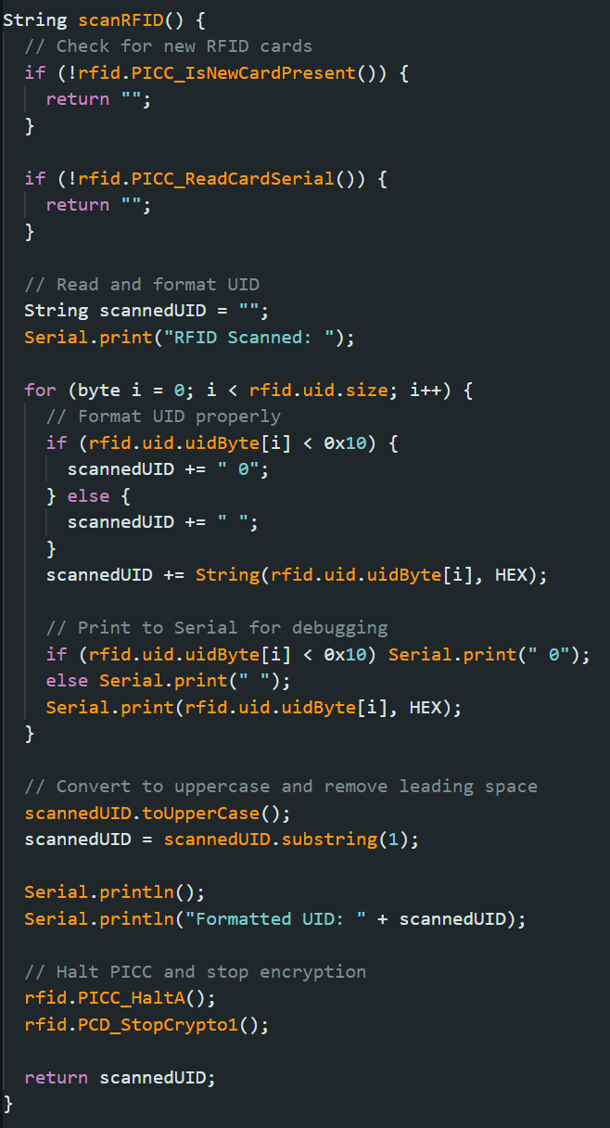
Figure 22:RFID Scanning Function
This function scanRFID() handles the process of detecting and reading RFID cards. It first checks if a new card is present and then retrieves the card’s UID (Unique Identifier). The UID is formatted into a readable string, converted to uppercase, and cleaned of extra spaces. For debugging, the UID is also printed in the Serial Monitor. Finally, the function halts communication with the card and returns the formatted UID. This allows the system to compare the scanned card ID with stored authorized IDs to decide whether to grant or deny access.
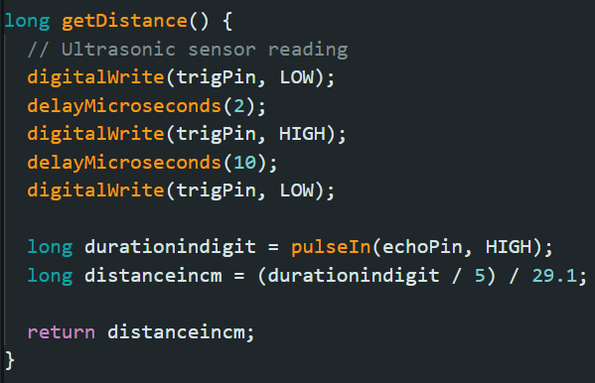
Figure 23:Ultrasonic Distance Measurement Function
The getDistance() function uses the HC-SR04 ultrasonic sensor to measure object distance. It sends a trigger pulse, listens for the echo, and records the return time with pulseIn(). This duration is converted into centimeters, allowing the system to classify objects into safe, warning, or danger zones.

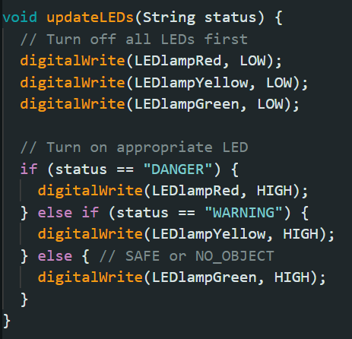
Figure 24:LED Status Indicator Function
The updateLEDs() function controls the red, yellow, and green LEDs based on the system’s status. It first turns off all LEDs, then lights up the appropriate one: red for danger (unauthorized access or critical distance), yellow for warning (object detected, needs verification), and green for safe or no object. This provides a clear and intuitive traffic-light style visual feedback for the user.
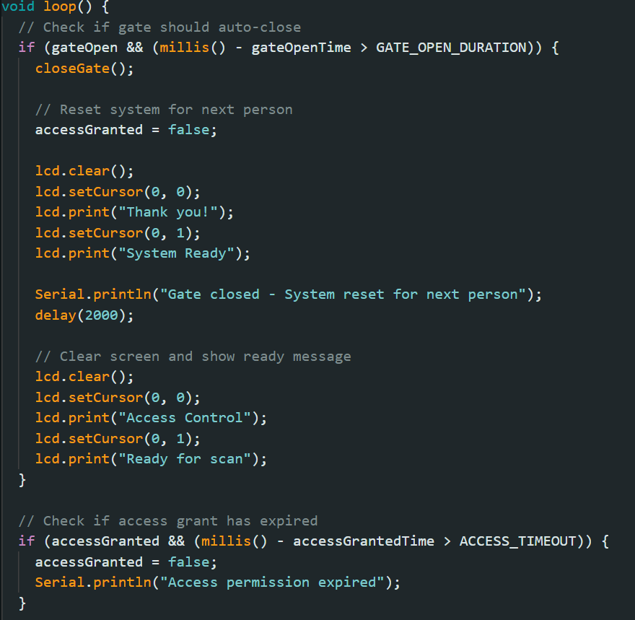
Figure 25:Auto-Close and System Reset Logic
This loop() section ensures the gate closes automatically after the set duration and resets the system for the next user. When the gates open time exceeds GATE_OPEN_DURATION, it calls closeGate(), thanks the user on the LCD, and returns to “System Ready.” It also checks if an access grant has expired based on ACCESS_TIMEOUT, revoking permission if time runs out. This keeps the system secure, responsive, and ready for the next scan.
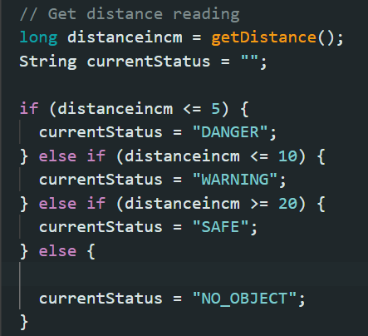
Figure 26:Distance-Based Status Detection
This code reads distance from the ultrasonic sensor using getDistance() and classifies it into zones. If the object is ≤ 5 cm, status is set to DANGER; if ≤ 10 cm, it becomes WARNING; if ≥ 20 cm, it’s marked as SAFE. Otherwise, the system assumes NO_OBJECT. These zones help the system decide when to trigger LEDs, buzzer alerts, or require RFID verification.
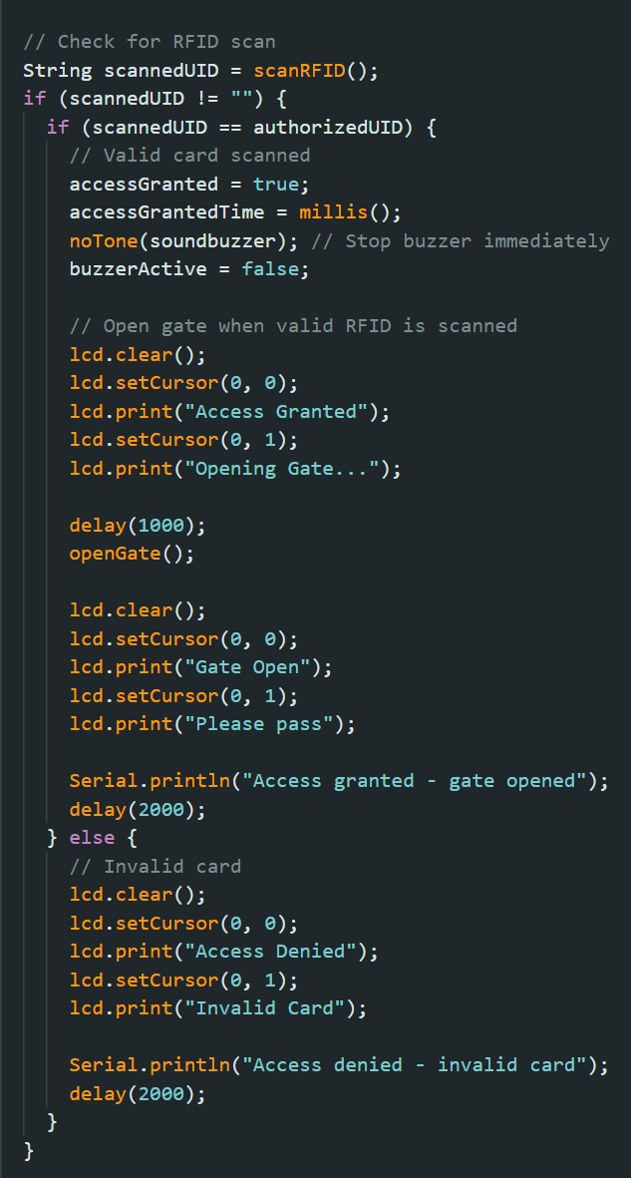
Figure 27:RFID Authentication Logic
This code handles RFID card scanning and access control. When a card is scanned using scanRFID(), its UID is compared with the stored authorized UID. If valid, the system grants access, stops the buzzer, updates the LCD with “Access Granted” and “Gate Open,” and triggers the servo to open the gate. If invalid, the LCD shows “Access Denied” and the system remains locked. This ensures that only authorized users can pass through the gate.

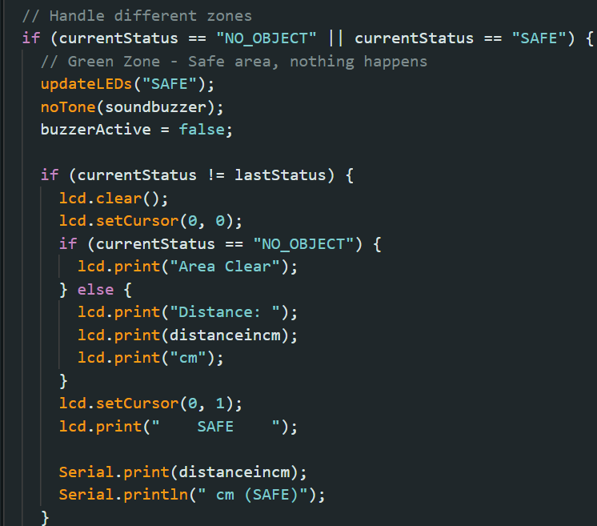
Figure 28:Safe and Clear Zone Handling
This code handles the SAFE and NO_OBJECT zones detected by the ultrasonic sensor. If no object is detected or the area is safe, the system turns on the green LED, silences the buzzer, and updates the LCD to show either “Area Clear” or the distance measured with a SAFE status. This ensures users know when the monitored space is secure and free from unauthorized proximity.
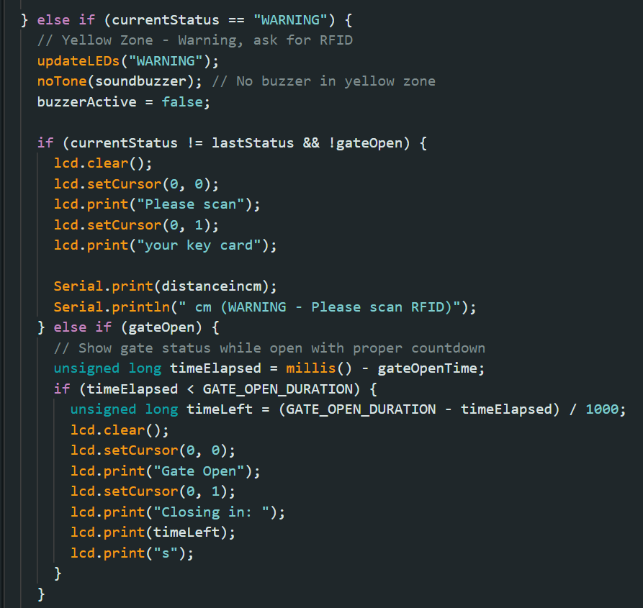
Figure 29:Warning Zone Handling
This code manages the WARNING zone, where an object is detected within a medium distance. The yellow LED turns on, the buzzer stays silent, and the LCD prompts the user to “Please scan your key card.” If the RFID is scanned and the gate opens, the LCD shows the gate status with a countdown timer until it automatically closes, ensuring smooth user interaction and security control.
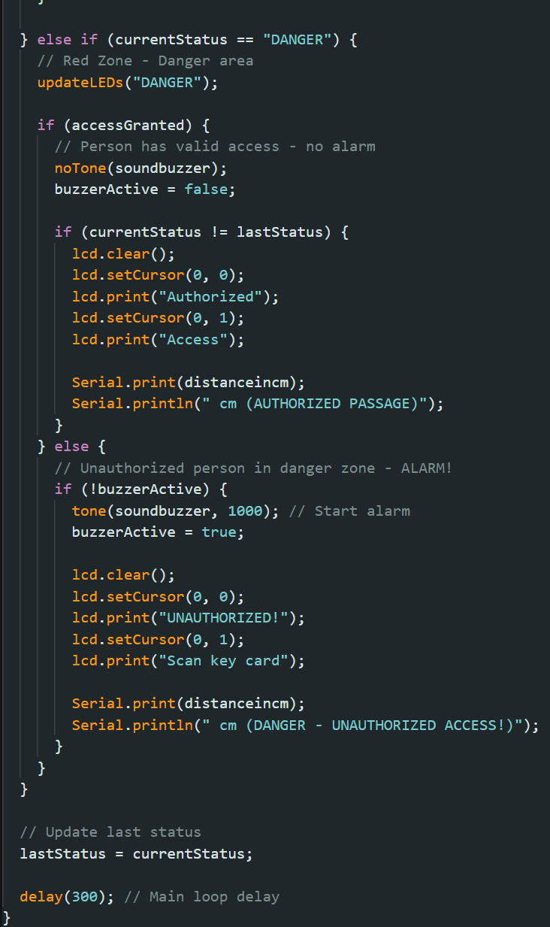
Figure 30:Danger Zone Handling
This code handles the DANGER zone, where an object is very close to the gate. If the person has valid RFID access, the system allows safe passage with no alarm, showing “Authorized Access” on the LCD. However, if access is not granted, the buzzer sounds an alarm, and the LCD displays “UNAUTHORIZED” along with a prompt to scan the card. This ensures intruders are detected immediately while still allowing authorized users to pass safely.

6.0 Limitations
Although the Ultrasonic RFID Security Gate System provides effective access control, it has some limitations. The ultrasonic sensor may give inaccurate readings in noisy environments or with irregular objects, and the RFID module has a short range and can be affected by damaged or blocked cards. The passive buzzer offers only basic audio feedback, which may be insufficient in loud areas. The system also relies heavily on the Maker UNO, which limits scalability, and it lacks encryption, making it vulnerable to RFID spoofing or card cloning in real-world use.

7.0 Future Enhancement
The system can be improved by adding encrypted RFID cards to prevent cloning, integrating stronger buzzers or alarms for better alerts, and replacing the ultrasonic sensor with more reliable technologies like infrared or camera-based detection. Wi-Fi or IoT connectivity could also be added for remote monitoring and logging of access records.

8.0 Conclusion
The Ultrasonic RFID Security Gate System successfully integrates Maker UNO, RFID authentication, ultrasonic distance sensing, LEDs, buzzer, LCD, and servo motor to create an efficient access control solution. It provides real-time feedback through visual, audio, and mechanical responses, ensuring secure and user-friendly operation. While it has certain limitations, the project demonstrates how affordable components can be combined to build a practical and scalable security system.

9.0 Reference
- Maker UNO: Simplifying Arduino for {Education}. (2025). Cytron Technologies Malaysia. https://my.cytron.io/p-maker-uno-simplifying-arduino-for-education#:~:text=Maker%20UNO%20was%201825%25%20funded,made%20easy%20with%20LED%20indicators.
- Hobby, S. (2021, April 11). How to make a RFID door lock with Arduino | Step by step instructions - SriTu Hobby. SriTu Hobby. https://srituhobby.com/how-to-make-a-rfid-door-lock-with-arduino/#google_vignette
- (2025). Youtube.com. https://www.youtube.com/watch?v=GOO84CGBPz8

